## According to many reference websites like https://data-flair.training they list top List of Cloud Service Providers in the market.

## And they are:

1. **Amazon web service (AWS)**
2. Microsoft Azure
3. Google Cloud Platform

And we have chosen according to many characteristics but first let’s show pros and cons of these servers

1. **Amazon web service (AWS)**

**pros:**

* AWS offers a complete toolset with a wide breadth of functions available for users
* AWS has been perfecting cloud computing services since 2006

**Cons:**

* AWS doesn’t have a strong hybrid cloud strategy for those businesses that want to keep sensitive data in a private cloud
* Enterprise level support **must be purchased**

So here we have to purchase to get these services and this project is for educational purpose

1. 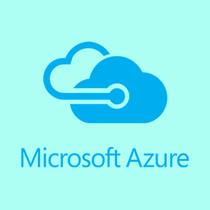 **Microsoft Azure**

**Pros:**

* Reliability and scalability
* High-availability

**Cons:**

* Functions seem limited when compared against AWS
* **Set up to support Windows**; if you want to run something else Azure may not be the best option

And as you can see in our project, we use another platform (Linux) that Windows Azure doesn’t support

1. **Google Cloud Platform**

**Pros:**

* Great reputation in open-source community
* Modern innovation, well-established in cloud computing
* Flexible pricing model

**Cons:**

* Supporting large, enterprise projects has not been a focus for Google when compared to companies like Microsoft

Here we found that it’s for free first, as we need and its cons doesn’t affect our project.

**References**:

* <https://data-flair.training/blogs/cloud-service-providers-companies/>
* https://www.bmc.com/blogs/aws-vs-azure-vs-google-cloud-platforms/